**Microcontrollers**

According to Wikipedia : A micro-controller is a small computer on a single integrated circuit containing a processor core, memory, and programmable input/output peripherals

**Arduino UNO**

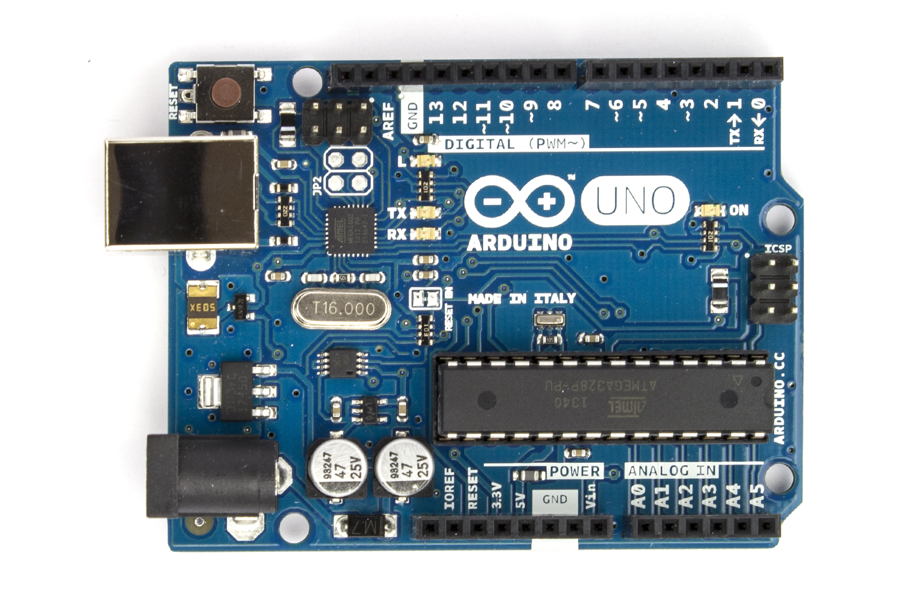

The Arduino Uno is a microcontroller board based on the ATmega328 ([datasheet](http://www.atmel.com/dyn/resources/prod_documents/doc8161.pdf)). It has 14 digital input/output pins (of which 6 can be used as PWM outputs), 6 analog inputs, a 16 MHz ceramic resonator, a USB connection, a power jack, an ICSP header, and a reset button. It contains everything needed to support the microcontroller; simply connect it to a computer with a USB cable or power it with a AC-to-DC adapter or battery to get started.

**IDE Download Links**

[**Windows**](http://arduino.cc/download.php?f=/arduino-nightly-windows.zip)

[**Mac OS X**](http://arduino.cc/download.php?f=/arduino-nightly-macosx.zip) **(10.7 Lion or newer)**

[**Linux 32 bit**](http://arduino.cc/download.php?f=/arduino-nightly-linux32.tar.xz)**,** [**Linux 64 bit**](http://arduino.cc/download.php?f=/arduino-nightly-linux64.tar.xz)

References :

<http://www.arduino.cc/en/main/arduinoBoardUno>

<http://www.princeton.edu/~ffab/media___downloads_files/IntroArduinoBook.pdf>